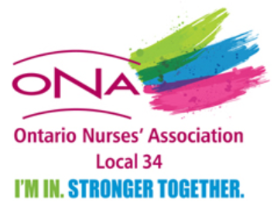
ONA Local 34
Rose Briscoe Bursary
APPLICATION FORM

Eligibility Criteria:

Applicants must be ONA Local 34 members with entitlements. Please attach to the application any information demonstrating that the following criteria have been met:

- Provide evidence (e.g. course outline) that the education relates to labour relations
- Education must be other than that sponsored or delivered by ONA or organizations to which ONA is affiliated
- Explain how the education will advance the goals of the union
- Agree to provide a written report to the Local President at local034@ona.org within 30 days of completion of the course
- Explain how the information obtained will be shared with members at the Local/Bargaining Unit level

- Scholarship funds will be provided to successful applicants upon proof of completion of the course.
- Successful applicants should endeavour to complete the education/ outreach within 12 months of notification of bursary approval.

Deadline:

Application must be received at local034@ona.org by April 1 each calendar year. If the maximum number of bursaries has not been awarded then applications received after April 1 will be considered. Successful applicants will be notified by mail within one month of the decision.

Name: _____________________________________________________________________
Address (including postal code): ___________________________________________________
Email: ________________________________________________________________________
ONA I.D. # _______________________________

Email your application to the following address: local034@ona.org

